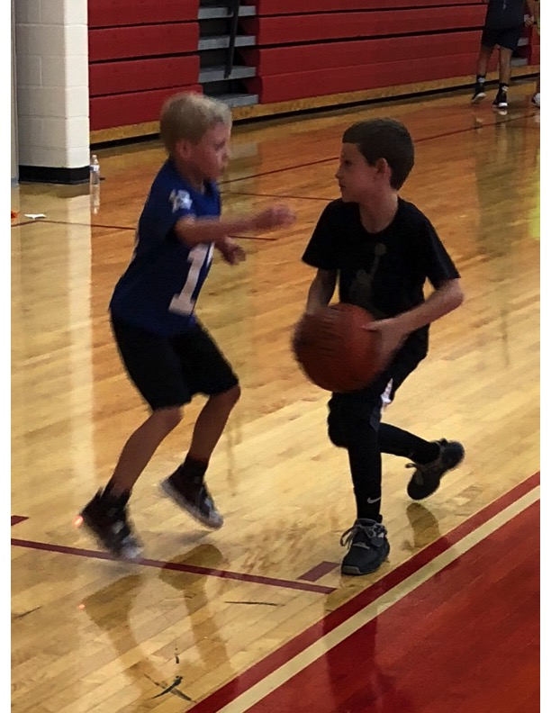  Practice Winning Every Day!  Fundamentals, Fun & Games  Grades entering 1st – 9th grade  Boys and Girls  $190 per camper / week  $165 / week if mailed in by May 17.  $160 per family camper / week  Add $50 extra for early drop off at 8 AM, M-F  Add $40 extra for late pick up at 4 PM, M-Th  Add $70 extra for early and late pick up  W.C. East H. S. Main Gym |  | WCASD does not sponsor or sanction  this camp  Future Viking Star Ellis Lane West Chester, PA 19382 Tom Durant, East Head Basketball Coach & Assistant Coaches and Viking players. kidfitsports2@gmail.com  W.C. East Viking Coed Full Day Basketball Camp P.O. Box 82 Westtown, PA, 19395 610-761-9035 Kidfitsports.com |  | W.C. East Vikings  Basketball Camps  - 9 to 3, M-Th, 9 to 12, Fri. Basketball Camp for 1st – 9th grade. Coed  - _____________________  - June 17 - 21  - June 24 - 28

r
West Chester East Vikings  - “Goals and making memories.” All about the team…# 1 seed for 10 weeks, Holiday Tournament Champs, Ches-Mont Final Four, District Playoffs & Championship, State Playoffs, Sportsmanship, and more to come…  West Chester Coaches and Players will be working hard to make your camp experience memorable. Join in on the fun!  East High School has one of the nicest facilities in the area. Ten baskets, shooting machine, safe, and friendly.  Concession stand for lunch and snack time. Pizza, beverage, snack options, desserts, etc. for purchase. Or campers may pack and bring your own. |  | 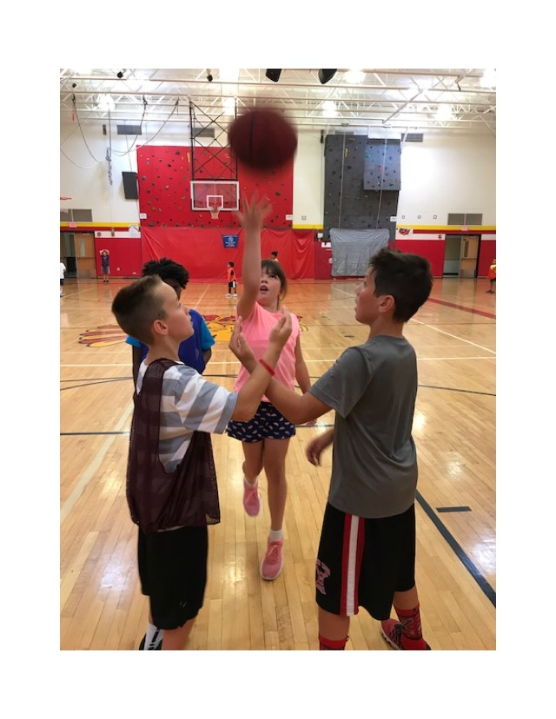  Hoop it up!  Campers can expect a lot of skill work incorporated in to various games and challenges. Our goal is to expose your child to a safe friendly learning environment while actively challenging them to get better! Typical Day at camp:  Morning: Proper Warm up, Director Talk, Station Work, Challenge of the Day,1 on 1, 2 on 2, 3 on 3 Free Throw Challenge, Lunch, Afternoon: 5 v 5, Individual Competitions, Group Challenges, Defensive Work, Team Basketball, Snack Time, Chalk Talk, Shooting Games, Exit Activity, Proper Cool down and wrap up. |  | Camper______________  Grade_____Gender____  Parent_______________________ Phone_______________________Email________________________  W.C. East Viking Basketball Camp $190/wk, $165 early bird/wk, $160/family member/wk  Check One(s) that apply: June 17- 21 __ extra $50 a.m. __ $40 p.m. __ $70 both __ June 24-28 __. extra $50 a.m. __ $40 p.m. __ $70 both __  Make all checks payable to: Tom Durant  - Mail to: P.O. Box 82, Westtown, PA 19395 (by May 17th and take $25 off) kfs site  Any Q? Tom Durant 610-761-9035  kidfitsports2@gmail.com  - I accept full responsibility for any injury to my son or daughter during camp activities. Every effort is made to protect the Health and Safety of the campers, but my child is insured and I shall not hold responsible any member of the WC East Viking Soccer Basketball Camp staff, faculty, or the school in the event of injury.  - Parent Signature & Date___________________

